**Server Side Web Programming II**

***1) FoodieShare - Student meal exchange platform***

« This project will allow students to share their culinary experiences, discover new dishes and make informed decisions when choosing where to eat on or near campus. »

The GitHub link:

<https://github.com/mikhailbiazverkhi/Laboratoire-1.git>

**Image :** Plateforme d'échange de repas étudiants.png

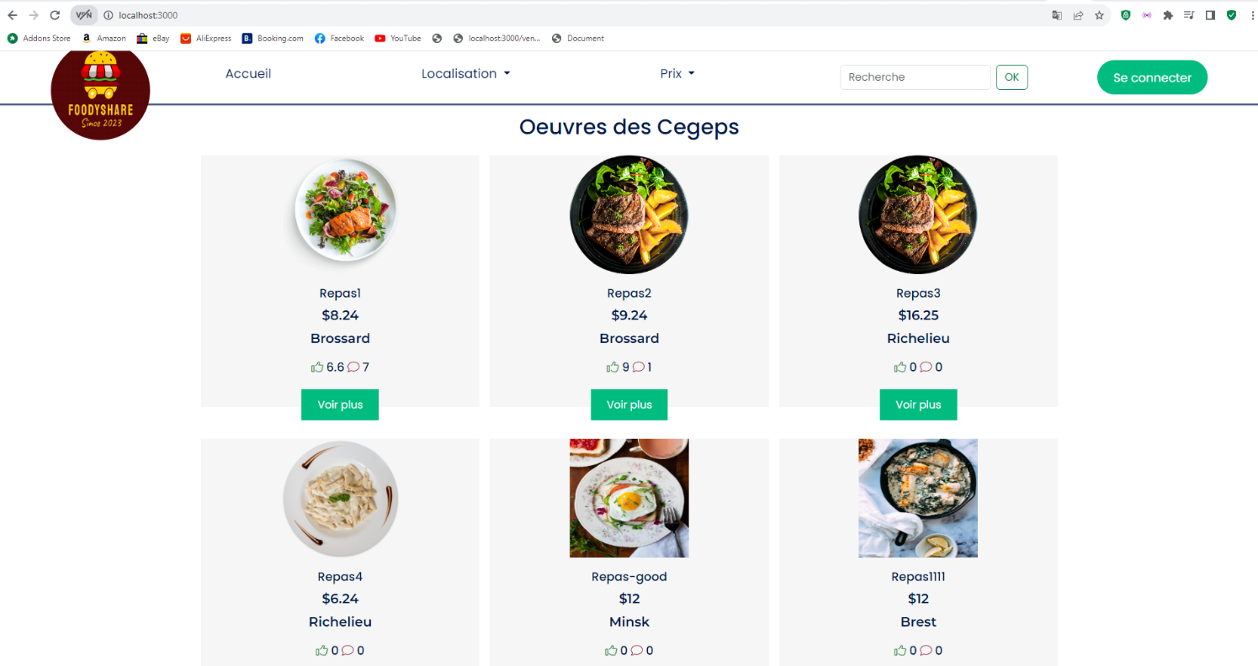

***2) RESTful API of the Blog platform***

« Transform your existing backend application (Blog Platform seen in the course) into an object-oriented RESTful API application »

The GitHub link:

<https://github.com/mikhailbiazverkhi/API-RESTful.git>

**Image :** API RESTful de la plateforme du Blog.png

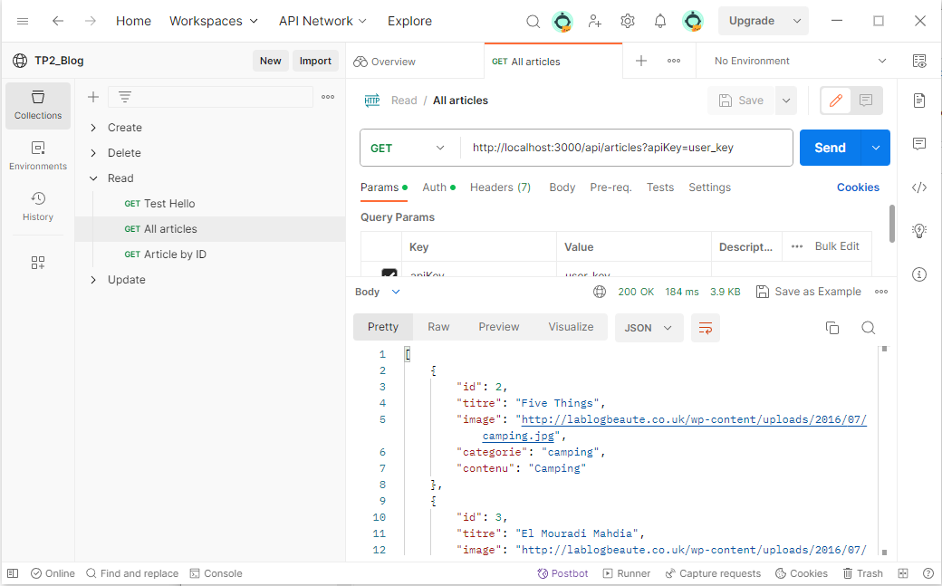

***3) Video Streaming Application***

« The objective is to implement a simplified video streaming platform where users can upload and list all uploaded videos by displaying the title, description, or category for each. »

The GitHub link:

<https://github.com/mikhailbiazverkhi/tp_final_p1.git>

**Image :** Application de Streaming Vidéo1.png

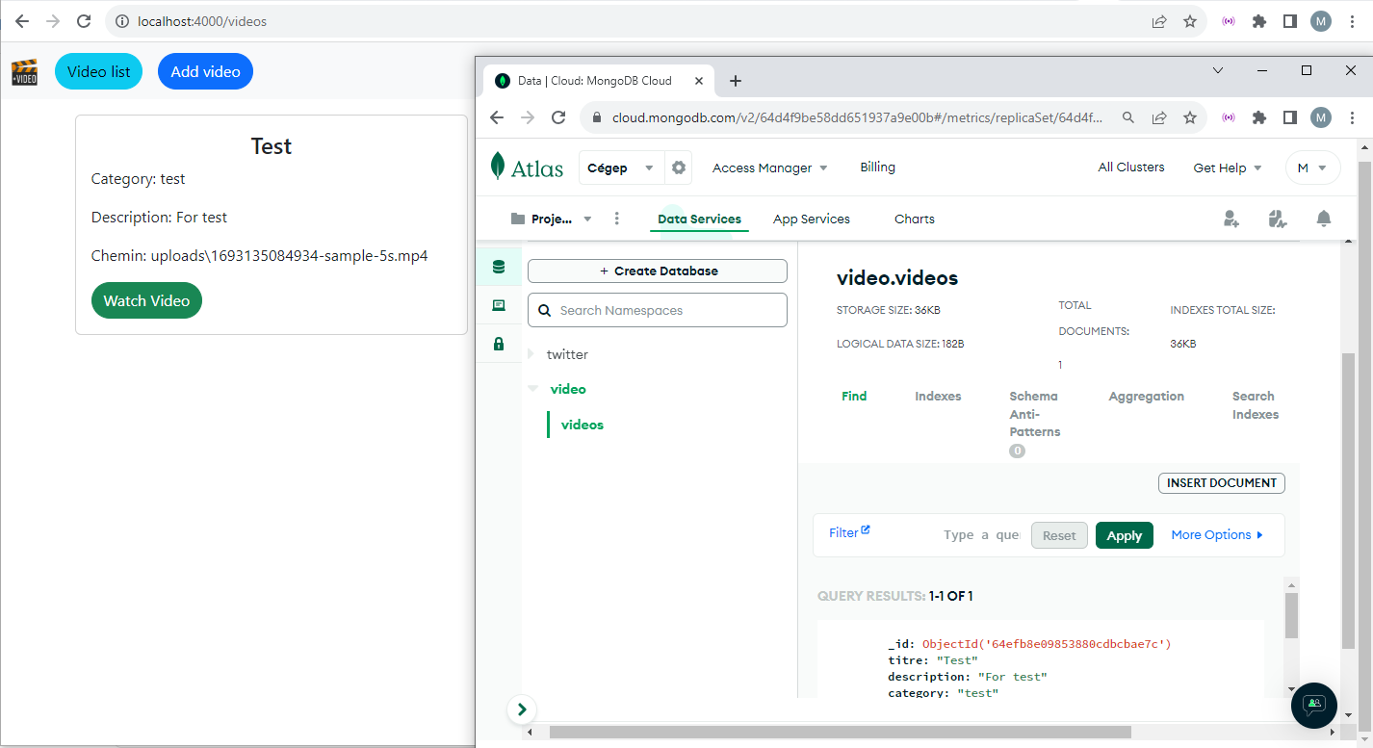

***4) Video Streaming Application (MVC)***

"Refactor your code to design it according to an advanced MVC architecture."

The GitHub link:

<https://github.com/mikhailbiazverkhi/tp_final_p2.git>

Image : Application de Streaming Vidéo_MVC.png

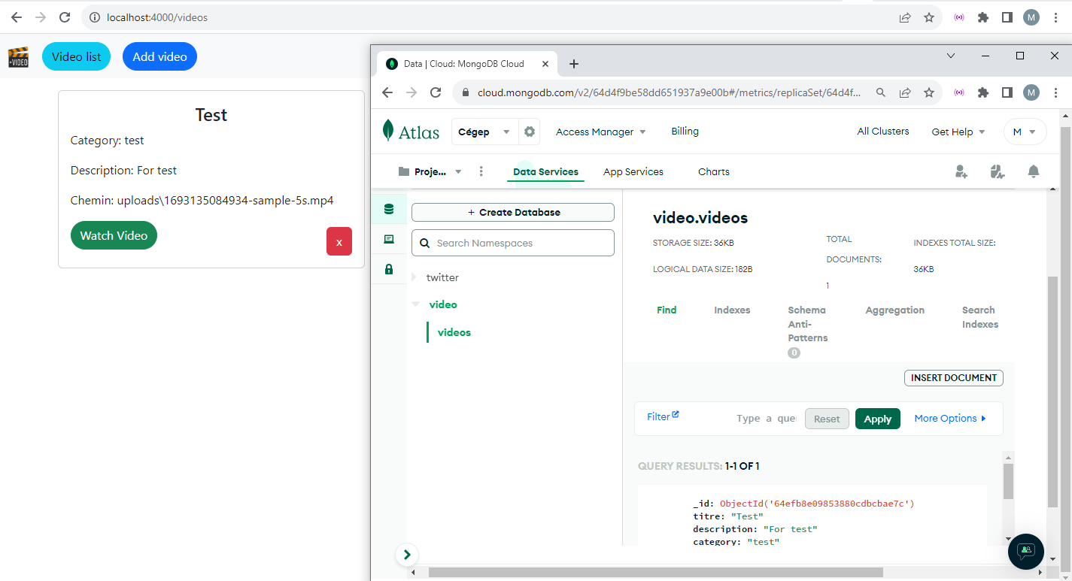

**Client-server interactive programming**

1. ***API and React***

« The owner of the Super Club had his idea stolen by a small company, Instagram. However, the coffee section was very popular. He would like you to transform the current application to React. You can leave out everything else that wasn't directly related to cafes. He also wants to add an e-commerce section to resell Nespresso products. »

The API is under development and documentation is available online <https://insta-api-api.0vxq7h.easypanel.host/api#/>

The GitHub link:

<https://github.com/mikhailbiazverkhi/tp2_react_new.git>

Image : API et React.png

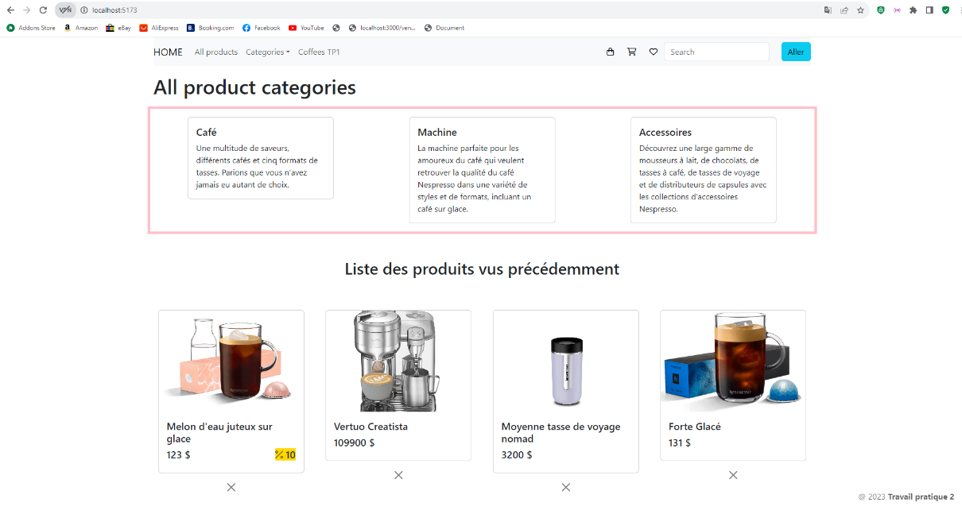

**Server Side Web Programming I**

1. ***Auction site (PHP)***

« The subject chosen is the creation of an eBay-style auction site. Anyone registered on the site can participate in the auction. Users of the site will therefore first have to register before being able to sell or buy items. »

The GitHub link:

<https://github.com/mikhailbiazverkhi/Encheres_PHP_MySQL.git>

Image : Enchères.png

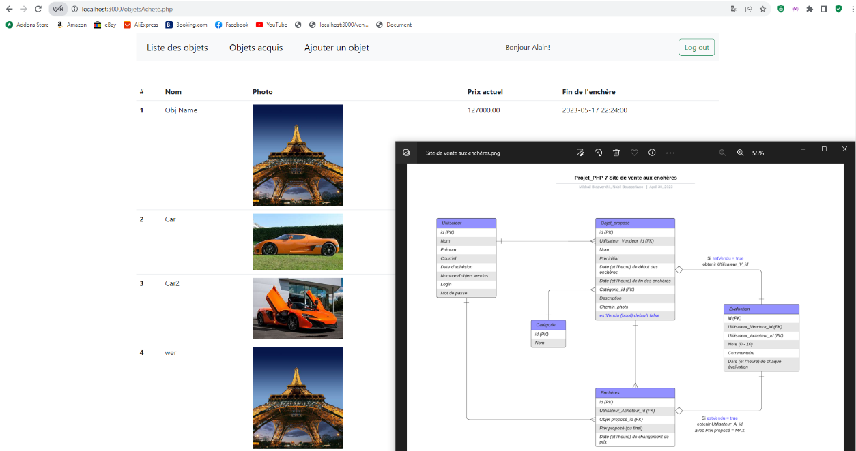

**Client-Side Web Programming II**

1. ***Website - Online store***

« You need to create an online store page (React) »

The GitHub link:

<https://github.com/mikhailbiazverkhi/Boutique-en-ligne_React.git>

Image : Boutique en ligne.png

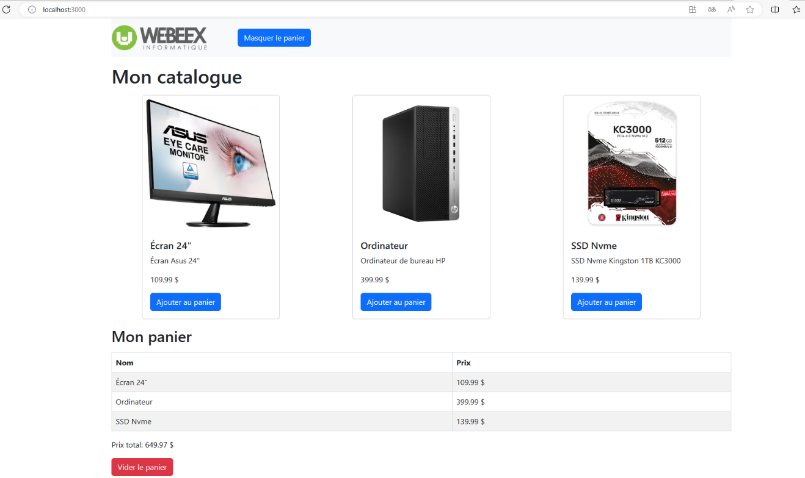

**Database**

1. ***Movie Database Management System with PHP and MySQL***

« Create a simple movie database management system using PHP and MySQL. This system must allow users to view, search, update and delete movie recordings while managing user authentication and access control. »

The GitHub link:

<https://github.com/mikhailbiazverkhi/DB-films_PHP-et-MySQL.git>

Image : Cinémathèque.png

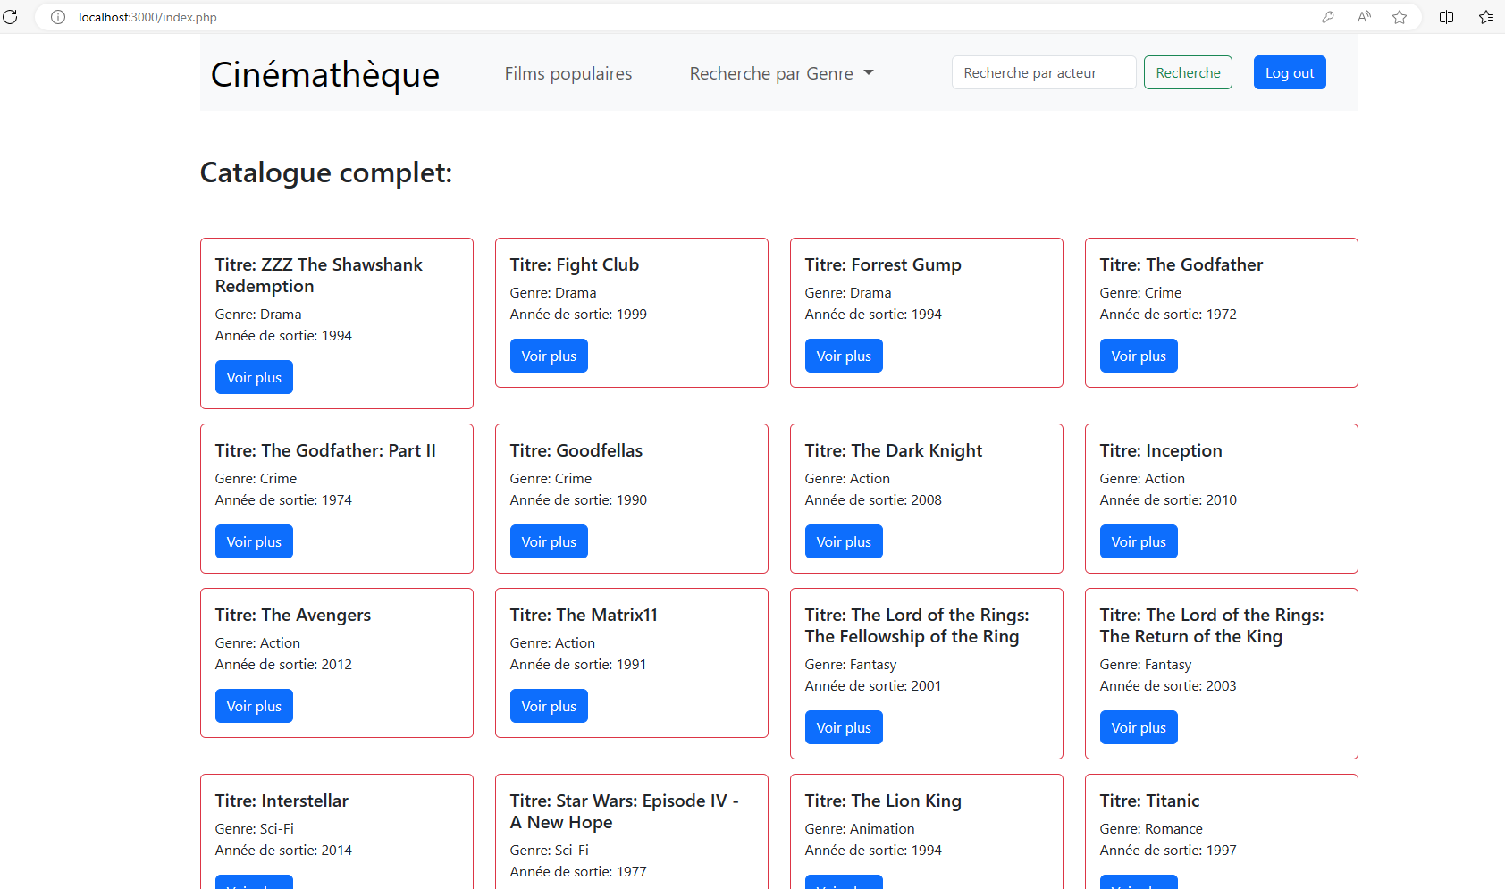

**Client-side web programming I**

1. ***Sportify (JavaScript)***

« Knowing your new skills in software development, someone close to you approaches you to tell you about a recently obtained Startup idea. Sportify, as it calls it, is a platform aimed at creating music playlists during training or physical efforts. »

The GitHub link:

<https://github.com/mikhailbiazverkhi/Sportify_JS.git>

Image : Sportify.png

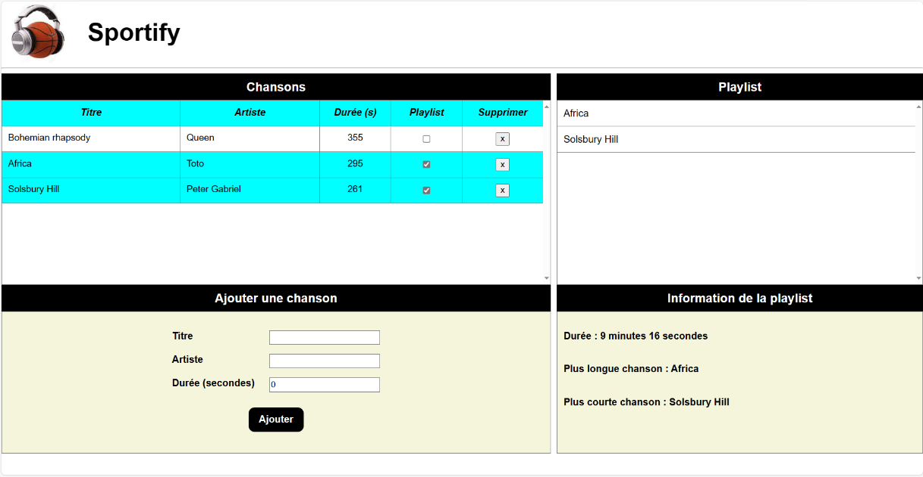

1. ***Van Gore (HTML et CSS)***

« The artist Vincent Van Gore, specialized in horror, is approaching you because he needs help developing his showcase site. In addition to painting canvases and creating other various works of art, Van Gore also has his small school where he gives private lessons and group lessons to people in the community. »

The GitHub link:

<https://github.com/mikhailbiazverkhi/Van-Gore_html_css.git>

Image : Van Gore.png

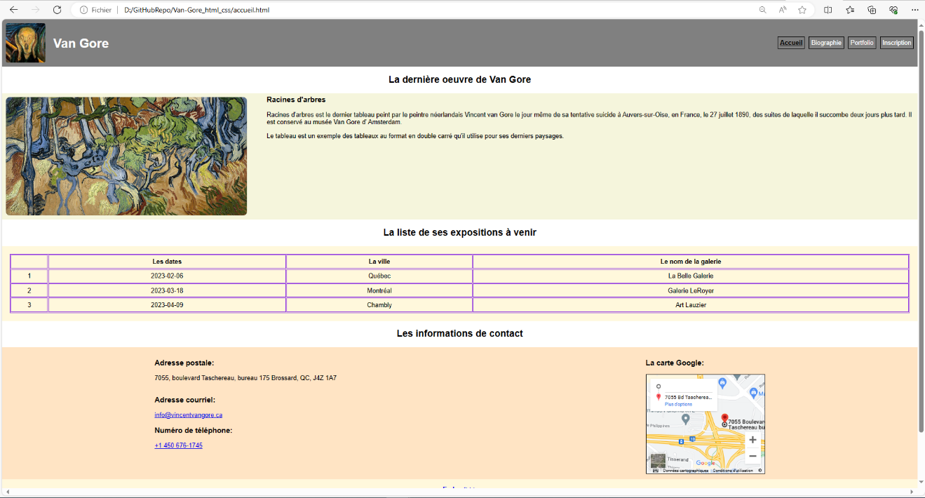

**Infographic elements for websites**

1. ***Model of the HabitationPlus site (AdobeXD and Photoshop)***

« Creation of a high-resolution model »

The GitHub link:

<https://github.com/mikhailbiazverkhi/Maquette-du-site-HabitationPlus.git>

Image : HabitationPlus.png.png

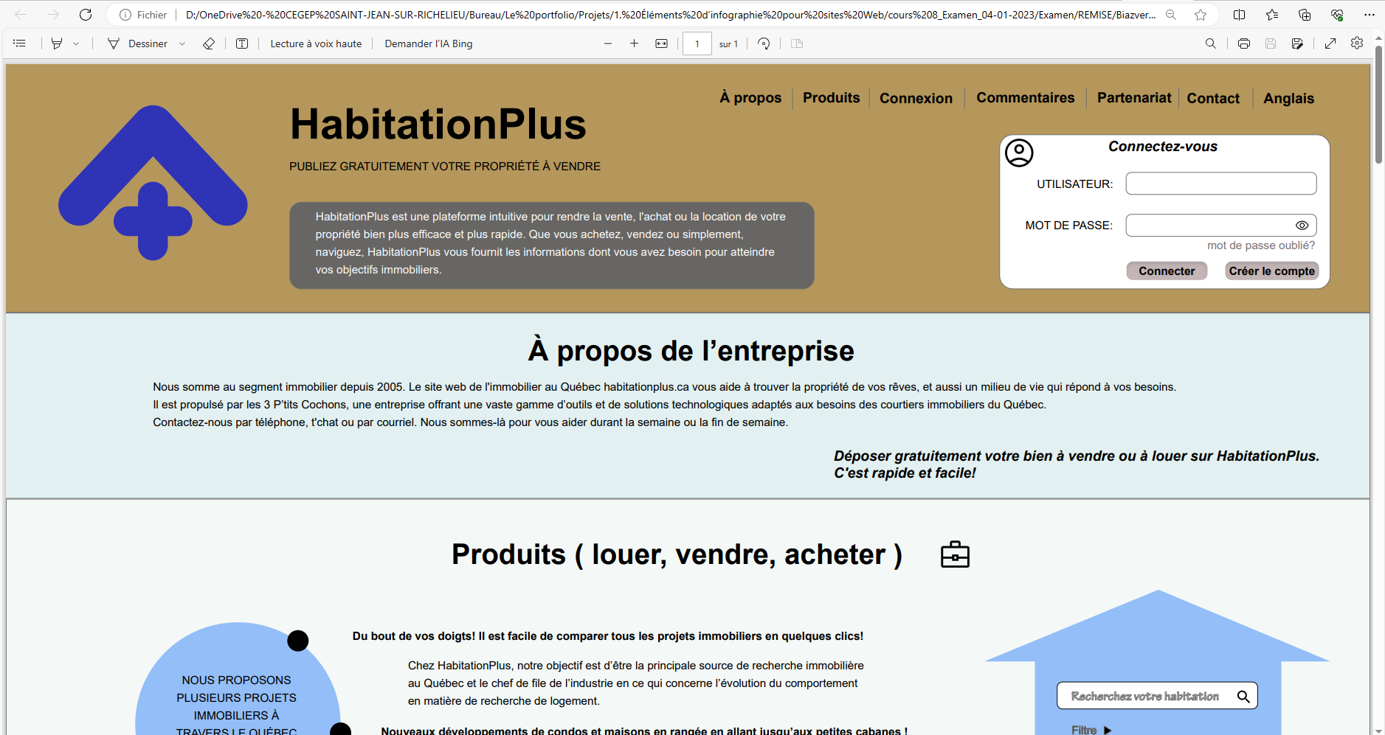

1. ***« Luxury Car » Website***

The GitHub link:

<https://github.com/mikhailbiazverkhi/Maquette-du-site-Voiture-de-luxe.git>

Image : Voiture de luxe.png

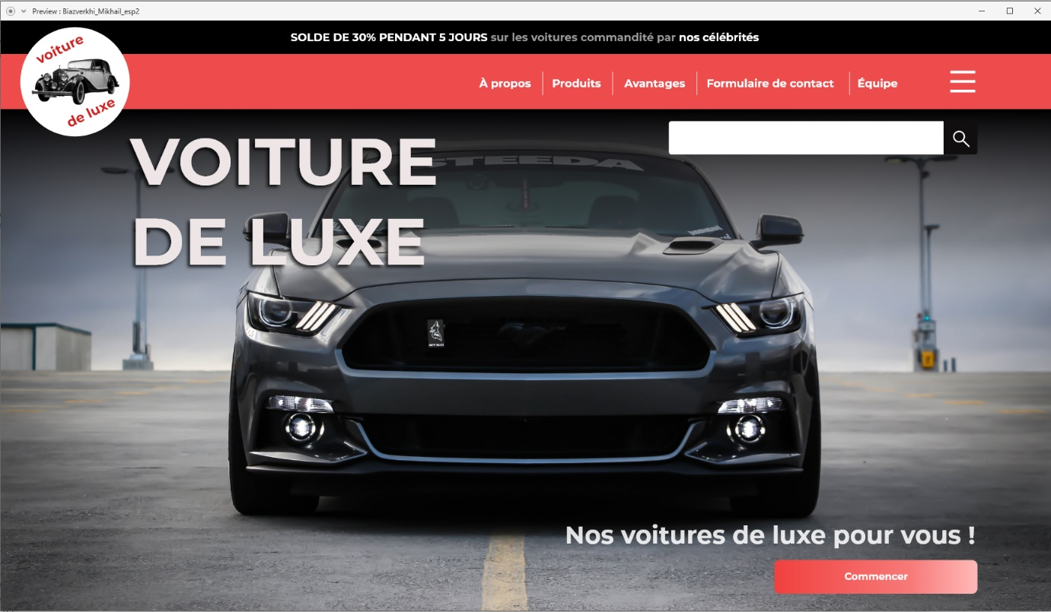

1. ***« Luxury car » website in mobile format***

The GitHub link:

<https://github.com/mikhailbiazverkhi/Maquette-mobile-Voiture-de-luxe.git>

Image : Voiture de luxe(mobile) .png

